Functional Requirements Document (FRD)

Digital Life Insurance Proposal Submission

1. Scope
The proposal submission module allows customers to apply for life insurance through a digital platform (web/mobile). The system captures customer information, validates inputs, stores proposal data, and forwards the proposal to the underwriting system.
The module will support:
- Personal information entry
- Policy details selection
- Nominee information capture
- Financial information capture
- Health declaration
- Lifestyle declaration
- Document upload
- Proposal submission

2. Systems Impacted
System | Impact
Customer Portal / Mobile App | UI for proposal submission
Pricing Engine | Premium calculation using actuarial models
Underwriting System | Risk evaluation
Policy Administration System | Stores proposal data
Document Management System | Stores uploaded files

3. Assumptions / Dependencies
Assumptions
- Customers will submit proposals digitally.
- Customers will provide accurate information.
Dependencies
- Integration with pricing engine for premium calculation.
- Integration with underwriting system for proposal processing.
- Integration with document management system.
- Integration with notification services.

4. As-Is Business Process
Current proposal submission process is manual.
- Customer fills a paper proposal form.
- Agent collects customer documents.
- Proposal is submitted to insurer.
- Imaging team scans documents.
- Data entry team enters information into system.
- Proposal is sent to underwriting.
Issues
- High operational cost
- Slow processing
- Manual data entry errors
- Poor customer experience

5. To-Be Business Process
The new system will allow digital proposal submission.
- Customer visits insurer website/mobile app.
- Customer requests insurance quote.
- System calculates premium using pricing engine.
- Customer proceeds to application.
- Customer fills proposal form online.
- Customer uploads documents.
- System validates inputs.
- System generates proposal number.
- Proposal is sent to underwriting system.

6. Functional Requirements
FR-01 Personal Information
System shall capture personal details.
Fields:
- Full Name
- Date of Birth
- Gender
- Mobile Number
- Email Address
- Residential Address

FR-02 Policy Details
System shall capture policy details.
Fields:
- Product selected
- Policy term
- Sum assured
- Premium frequency

FR-03 Nominee Details
System shall capture nominee information.
Fields:
- Nominee name
- Relationship with policyholder
- Nominee date of birth
Business rule:
- If nominee age < 18 → appointee/guardian details must be provided.

FR-04 Financial Information
System shall capture financial details.
Fields:
- Occupation type
- Employer name (optional)
- Annual income
- Income proof type

FR-05 Health Declaration
System shall capture health details.
Fields:
- Height
- Weight
- Existing illness (Yes/No)
- Illness details
- Previous surgeries
- Family medical history

FR-06 Lifestyle Declaration
System shall capture lifestyle information.
Fields:
- Smoking status
  - Non-smoker
  - Former smoker
  - Current smoker
- Alcohol consumption
  - None
  - Occasional
  - Frequent
- Hazardous activities participation

FR-07 Document Upload
System shall allow customers to upload required documents.
Mandatory documents:
- Identity proof
- Address proof
- Income proof
- Medical Illness/Allergies
Accepted formats:
- PDF
- JPG
- PNG

FR-08 Data Validation
System shall validate proposal data before submission.
Validation rules:
- Mandatory fields must be completed.
- Email format validation.
- Phone number format validation.
- Required documents must be uploaded.

FR-09 Proposal Submission
Upon successful validation:
- System generates a unique proposal number.
- Proposal data is stored in Policy Administration System.
- Proposal is forwarded to the underwriting engine.

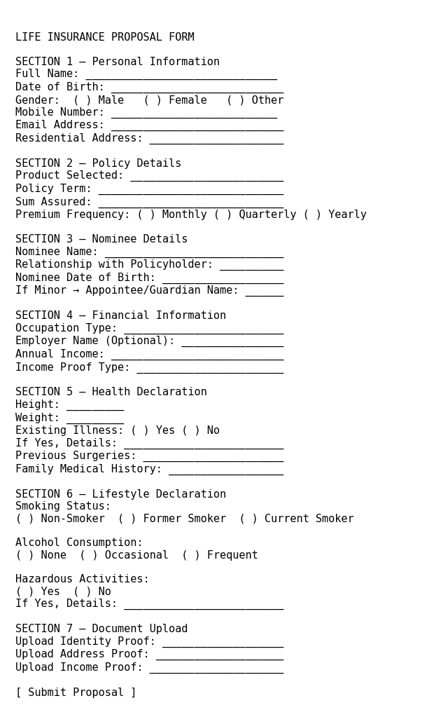
MOCKUP

